Klites Eats – Mess Management System

*A Project Based Learning Report Submitted in partial fulfilment of the requirements for the award of the degree*

*of*

**Bachelor of Technology**

**in The Department of CSE**

**AOOP - 23CS2103E**

Submitted by

**2310030075: CH. Varshith Kumar**

**2310030258: Prasad Reddy**

**2310030184: B. Sadhwika**

**2310030363: Hannah Christina**

Under the guidance of

**Anuradha Nandula**



Department of Computer Science and Engineering

Koneru Lakshmaiah Education Foundation, Aziz Nagar

Aziz Nagar – 500075

NOV - 2025.

**Abstract**

The "Klites Eats - Mess Management System" is designed to streamline mess operations by providing a user-friendly platform for students to interact with their dining services. This system addresses the prevalent issues of food wastage and inflexible payment structures often associated with traditional mess arrangements. The core functionalities include enabling students to register as users, view the daily menu, book meals on a particular day, and securely pay for their meals, with an automated receipt generation process. By implementing this system, food preparation can be optimized to match the precise number of students requiring meals, thereby minimizing waste. The system is developed using a combination of web technologies—HTML, CSS, and JavaScript for the front-end interface, Tomcat as the web server, and SQL for database management—to ensure a robust and efficient solution.

**Table of Contents**

|  |  |
| --- | --- |
| 1 | Abstract |
| 2 | Introduction |
| 3 | Methodology |
| 4 | Experiments (or System Design) |
| 5 | Results (or Implementation Details) |
| 6 | Conclusion and Future Work |
| 7 | References |

Klites Eats – Mess Management System

# **Introduction**

Traditional mess management systems, while serving the fundamental purpose of providing sustenance to students in residential settings, often grapple with inherent inefficiencies that lead to significant challenges. A primary concern is the pervasive issue of food wastage. Conventional systems typically operate on a pre-determined, fixed-quantity cooking model, where food is prepared in bulk to cater to the entire resident population. This approach disregards the daily fluctuations in student attendance at meals, resulting in excess food that is ultimately discarded. Such wastage not only represents a loss of valuable resources but also carries negative environmental and economic implications. Furthermore, the financial structure of many traditional mess systems presents another layer of inefficiency. Students are commonly required to pay a fixed mess fee, irrespective of their actual meal consumption. This arrangement becomes particularly disadvantageous for students who, due to academic commitments, personal preferences, or other reasons, frequently miss meals. In these cases, students end up paying for a service they do not fully utilize, leading to a perceived lack of value and financial dissatisfaction.

There is a clear and compelling need for a paradigm shift in mess management – a transition towards a more dynamic, responsive, and economically sound model. This necessitates the adoption of systems that can adapt to the real-time demands of student meal consumption, minimizing waste and ensuring fairness in pricing. The "Klites Eats" system is introduced as a comprehensive and innovative solution to address these long-standing challenges and revolutionize the way students interact with their dining services. This system aims to optimize mess operations by leveraging technology to create a more efficient, transparent, and user-centric experience.

The primary purpose of the "Klites Eats" system is to provide an efficient and intelligent platform that effectively manages mess operations, significantly reduces food waste, and offers a convenient and equitable pay-as-you-eat model for students. By accurately forecasting meal demand and tailoring food preparation accordingly, the system seeks to minimize surplus food and the associated wastage. Moreover, it empowers students with greater control over their meal expenses, allowing them to pay only for the meals they consume.

Key objectives of the "Klites Eats" system include:

* **Seamless Student Registration and Profile Management:** The system will provide a user-friendly interface for students to register their details, manage their profiles, and securely store their dietary preferences and any allergy information.
* **Accessible Daily Menu Viewing:** Students will have easy access to the daily menu through a digital platform, enabling them to make informed decisions about their meal choices. This feature promotes transparency and allows students to plan their meals in advance.
* **Efficient Online Meal Booking:** The system will facilitate online meal booking, allowing students to reserve their meals for a specific day. This booking information will be used to accurately estimate the required food quantity, thereby minimizing overproduction.
* **Secure Online Payment Processing:** The system will integrate secure online payment gateways to enable students to pay for their meals conveniently and safely. This eliminates the need for cash transactions and provides a streamlined payment experience.
* **Automated Transaction Receipt Generation:** Upon successful payment, the system will automatically generate digital receipts, providing students with a clear record of their transactions. This feature enhances transparency and simplifies accounting.

The scope of the "Klites Eats" system is carefully defined to ensure a focused and effective implementation. The system is primarily designed for use by student residents within a specific institution or hostel. It encompasses the management of regular daily meals (e.g., breakfast, lunch, dinner) served at the mess. The system will support standard online payment methods to provide flexibility to students. Furthermore, the system includes essential administrative functions for mess staff to manage menus, track bookings, and generate reports. This scope definition ensures that the system effectively addresses the core needs of mess management while remaining manageable and implementable.

# **METHODOLOGY**

The development of the "Klites Eats" system employs a structured methodology that integrates diverse technological components to achieve its objectives effectively. The system architecture is designed to facilitate seamless interaction between its various parts. It comprises a client-side, a server-side, and a database. The client-side, built using HTML, CSS, and JavaScript, provides an interactive and user-friendly interface for students. This interface allows students to register, view menus, book meals, and make payments. The server-side, powered by Tomcat and utilizing Java Servlets/JSP, handles the application's logic. It processes user requests, manages data, and generates dynamic responses. A SQL database is used for persistent data storage, ensuring that information related to users, menus, bookings, and payments is securely stored and readily accessible.

The system is organized into several key modules, each responsible for a specific functionality:

* **User Registration Module:** Manages student accounts, allowing students to register and maintain their profiles.
* **Menu Management Module:** Handles the creation, updating, and display of daily menus.
* **Meal Booking Module:** Facilitates the online booking of meals by students.
* **Payment Processing Module:** Ensures secure and efficient transaction processing.
* **Receipt Generation Module:** Automatically generates receipts for successful transactions.

The selection of technologies was deliberate and based on their suitability for the project's requirements. HTML, CSS, and JavaScript were chosen for their ability to create rich and interactive user interfaces. Tomcat was selected as the web server due to its robustness and efficiency in handling web applications. Java Servlets/JSP were used for server-side processing, providing the necessary logic and functionality. SQL was chosen for its efficient database management capabilities, ensuring data integrity and accessibility.

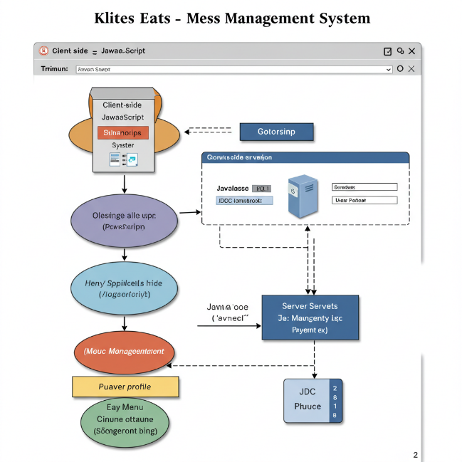

# **EXPERIMENTS**

The design of the "Klites Eats" system prioritizes user experience and efficient data management to meet the specified requirements. The User Interface Design focuses on creating intuitive and user-friendly web pages for registration, menu display, booking, and payment processes, with considerations for layout, navigation, and accessibility. Wireframes or mockups are utilized to visualize the structure and functionality of these pages. The Algorithm/Logic Design involves the development of specific processes such as calculating meal costs based on selections and generating unique booking IDs to manage reservations effectively. Data Flow Diagrams are employed to illustrate how information moves through the system during key operations like user registration and meal booking, ensuring clarity and efficiency in data processing.

# **RESULTS**

The implementation of the "Klites Eats" system involves translating the design specifications into a functional application. The Implementation Details cover the development of each module, including database connectivity, meal booking procedures, and secure payment gateways. Code snippets are included to demonstrate key functionalities and highlight important aspects of the implementation. User input validation and error handling mechanisms are integrated to ensure data integrity and system reliability, while security measures are implemented to protect user data and financial transactions. Screenshots of the working system are provided to illustrate the user interface and demonstrate the functionality of each module, such as the registration page, daily menu, booking form, payment confirmation, and generated receipt. The Testing process involves a series of evaluations, including unit testing, integration testing, and user testing, to verify the system's functionality, performance, and usability.

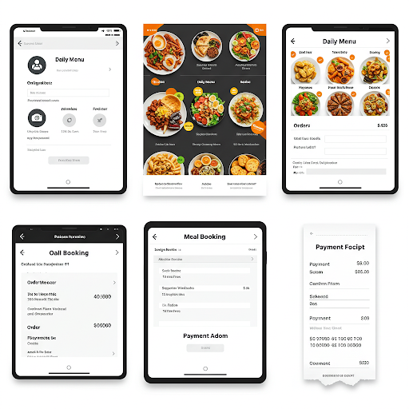

# **CONCLUSION and FUTURE WORK**

In conclusion, the "Klites Eats - Mess Management System" provides a robust solution to the inefficiencies of traditional mess systems by minimizing food waste and offering a flexible payment structure. The system effectively meets its objectives by providing essential functionalities such as user registration, menu viewing, meal booking, and payment processing. The benefits of this system include significant reduction in food wastage, cost savings for students, and improved management of mess operations. Future Work may involve incorporating additional features to enhance the system further. Potential enhancements include a feedback system for meal ratings, a notification system for booking reminders, integration with student ID card systems for streamlined payments, and the generation of detailed reports on meal consumption patterns.

##### **References**

This section lists all the resources that were consulted and utilized during the development of the "Klites Eats - Mess Management System." These references may include online tutorials, documentation for the technologies used (HTML, CSS, JavaScript, Tomcat, SQL), and books or articles on web development and database management. A consistent citation style is followed to give proper credit to the sources and allow readers to access them for further information.